**Random Variable Generation**

By: Joshua McDonald & Ni Li

**TABLE OF CONTENT**

1. Abstract
2. Background
3. Objective
4. Key Findings
5. Conclusions
6. Sample Simulation Modeling
7. Appendix with miscellaneous tables, figures, etc.
8. **Abstract**

Random variate generation is a fundamental aspect of simulation modeling and analysis. The objective of random variate generation is to produce observations that have the stochastic properties of a given random variable. To this end, we have developed a library to generate random variates using programing language go that are convenient to use. Please refer to our coding document for the library detail.

1. **Background**

Given an experiment with a set of possible outcomes, a random variable is defined as a measurable function from the set of possible outcomes to a measurable space. Random variate generation is the process of producing observations that have the stochastic properties of a given random variable. The ability to produce stochastic simulation models for the purpose of analysis and decision making relies heavily on the use of random variate generators. As such, the topic of random variate generation appears in many papers throughout the history and continues today.

1. **Objective and Concepts**

The objective of random variate generation is to produce sample observations that have the stochastic properties of a given random variable, X, having distribution function: F(x) = Pr(X ≤ a) (−∞ < a < ∞). The primary concepts on which many random variate generators are developed appear in early work by von Neumann (1951), Yagil (1963), Butler (1956), and Teichroew (1953, 1965) described below:

* **The Inverse Transform Method**

The inverse transform method utilizes the inverse of the cumulative distribution function (cdf) of the random variable under consideration to generate observations. The general approach is as follows:

Given a random variable X with cdf F(x), generate a U(0,1) random number u corresponding to the *u*th fractile of the cdf, F(x) = u. The value of the random variate generated is the value of x such that, x = F−1 (u).

* **The Composition Method**

Situations arise in which a density function (f), can be written as a weighted sum of r other densities (Cheng 1998): , where *p* >0 and the sum of *p* equals to 1. The density f is referred to as a compound or mixture density.

* **The Acceptance–Rejection Method**

The acceptance–rejection method is often used when a closed-form cumulative distribution function does not exist or is difficult to calculate. In this method, variates are generated from one distribution and are either accepted or rejected in such a way that the accepted values have the desired distribution. Schmeiser (1980) presents the following general acceptance–rejection algorithm:

Given a random variable X, let f(x) denote the desired density function of X. Let t(x) be any majorizing function of f(x) such that t(x) ≥ f(x) for all values of x. Let g(x) = t(x)/c denote the density function proportional to t(x) such that c = . The steps are:

1. Generate x ∼ g(x).

2. Generate u ∼ U(0,1).

3. If u > f(x)/t(x), then reject x and go to step 1.

4. Return x

1. **Key Findings**

**Understanding Steady State Traffic**

Exploring causes of Traffic in steady state traffic in the downtown Saint Paul area. This allows us to understand traffic flow in the absence of traffic flow towards the Xcel Center to understand normal, day-to-day traffic flow.

The purpose of these simulation experiments is to better understand how structural characteristics such as traffic light frequency, driver behavior, and structural limitations give rise to normal traffic conditions. To modify the real situation, we used 500 random background private vehicles, 5 random background buses, 1200 maximum number of steps with 1 step per second, fixed traffic timing, Dijkstra routing algorithm for new routes as our simulation settings.

Using SMARTS, we defined several root causes of traffic congestion:

1. Too much traffic for the available physical capacity to handle due to the poorly intersection design. **Figure 2** (below) is a screenshot of our simulation shows the real time traffic condition at two of the intersections near Xcel Energy Center. Both observation 1 and 2 shows the traffic flow breaks down at one intersection. There are close by intersections are so close, which restrict the space between these two intersections to accommodate the waiting cars at the first intersection. Then, the adjacent intersection gets affected and congested as well. Slowly, the trend of congestion keeps spreading around the area, fewer and fewer cars can get through those intersections. These locations eventually become bottleneck with the flow of traffic.

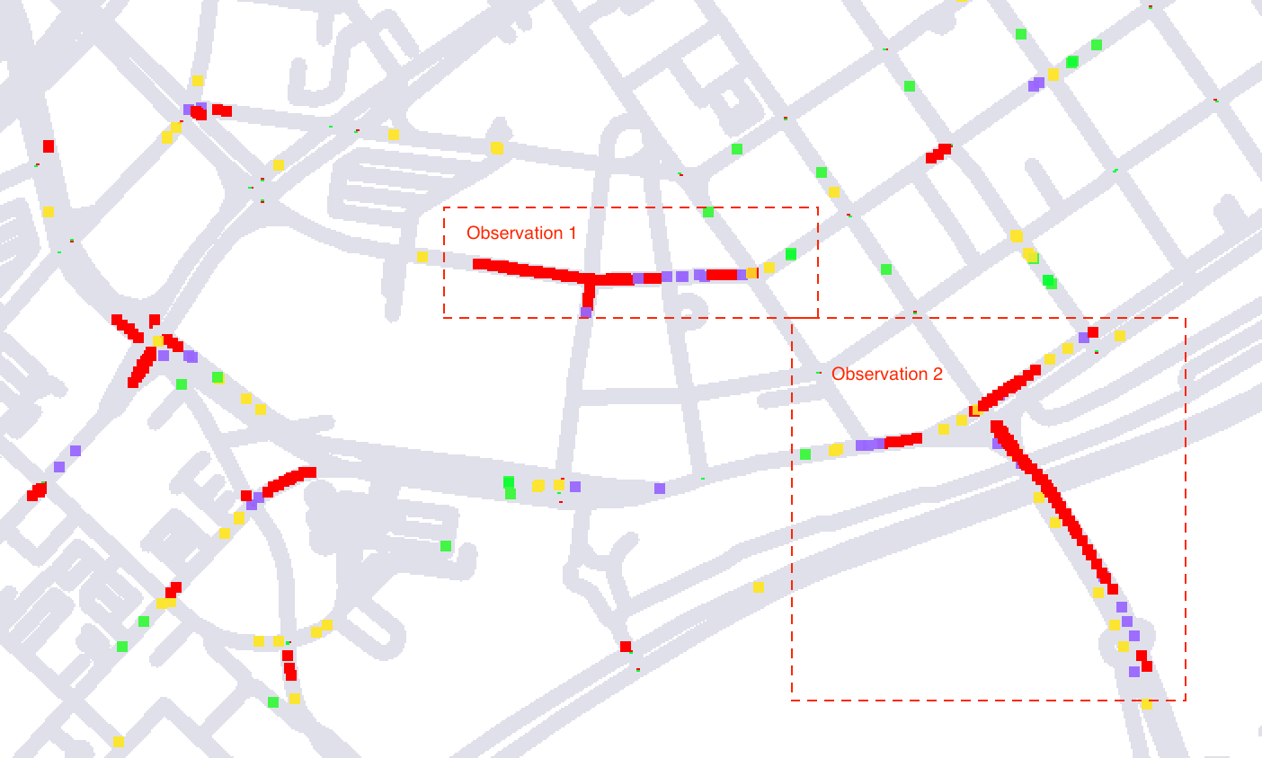

**Figure 2:** traffic congestion affecting multiple intersections

1. Traffic lights signals are poorly timed at certain intersections. For instance, if you follow a car who hit a red light at one of the intersections in the triangle area labeled as observation 3 in **Figure 3** (below), you will notice this car will possibly hit red light at the next intersection in the triangle area. This can be caused possibly by hysteresis loops on the road. The traffic lights for a continuous speed. If a car was lucky enough to make it through the first one on green, and most likely this car will catch every green light thereafter. However, the traffic management system was not smart enough to avoid car getting every red light all the way through.

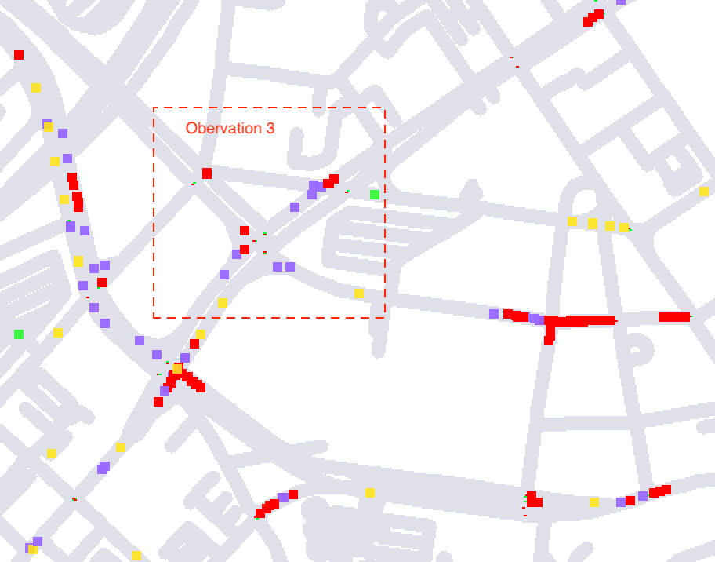

Figure 3: Traffic congestion at the triangular roads

1. Another problem we have observed is that if the traffic flow at one direction tends to be heavier than the other direction, this situation will continue and even getting worse on the heavy traffic direction. For example, at the observation 1 location in figure 2 above, the traffic jam starts on the street which runs from east to west. Then, the traffic on the street keeps getting heavier and heavier until both east to west and north to south direction get clogged. According to the traffic needs, the traffic lighting system should be adjusted dynamically to extend the green light timing in the direction which has a much heavier traffic than the other one since that direction start jamming. In that way, there are more cars can be released at the beginning, which can help with the traffic when the road gets busier.

With the real-time traffic monitoring using SMARTS, we can illustrate where and when the heavy traffic occurs, where public buses, taxis, other modes of transit are located, and other insight detailed data to reflect the specific needs in traffic control for each location. All the information can be used in monitoring for creating smart traffic management system like **Figure 4** (below) and eventually make travel throughout the city more efficient and environmentally sustainable.

**Figure 4:** Block Diagram of the smart traffic management system

**Characterizing Xcel Center-based Traffic Jams**

We conducted experiments to study traffic flow from the greater downtown area to the Xcel Energy Center. This was conducted by selecting a destination bounding box representing an area directly adjacent to the Xcel Energy Center, which contains parking ramps that are common arrival destinations for attendees. We compared dynamic lighting control to fixed traffic control under varying traffic loads. We selected traffic loads of 100, 500, and 1,000 vehicles for our simulation. Where 100 vehicles serves as a low-load baseline, 500 vehicles represent moderate load, and 1,000 vehicles represents a high load scenario.

|  |  |  |
| --- | --- | --- |
| **Traffic Light Timing** | **Number of Vehicles** | **Average Travel Speed (km/h)** |
| **Dynamic** | **100** | **13.9** |
| **Dynamic** | **500** | **5.8** |
| **Dynamic** | **1000** | **3.7** |
| **Fixed** | **100** | **14.3** |
| **Fixed** | **500** | **5.7** |
| **Fixed** | **1000** | **3.7** |

***Table 1:*** *Average Travel Speeds during Travel to the Xcel Center destination under Dynamic and Fixed Traffic Lighting*

The results of our experiment our presented in **Table 1** (above) and indicate that travel speed is highly similar between dynamic and fixed lighting schemes. Conversely, low travel speeds are highly correlated with the number of vehicles on the road. Together, these results suggest that the traffic issue is more likely a function of the existing infrastructure limitations rather than unintelligent traffic light schemes. Visual inspection of traffic across the downtown Saint Paul road network at the conclusion of the simulation can be found in **Figure 5** (below). These results demonstrate that congestion occurs at similar locations under both conditions regardless of the lighting system used, suggesting physical limitations of the network.

Congestion appears highly similar across n = 100 and n = 500 for both dynamic and fixed traffic light controls. However, traffic appears notably worse for the fixed traffic system at n = 1,000. These results suggest that as traffic volume increases, lighting control becomes a more significant factor.

It is interesting that the traffic backlog reflected for the fixed traffic light control at n = 1,000 is not represented by the travel speed. These results represent the traffic load at the conclusion of the simulation, not when every vehicle has reached their destination. It could be that slower travel times are occurring in the fixed light scenario but that longer simulation times are necessary to capture them. A future direction of our work is to extend the duration of our simulation to see if differences between traffic light conditions become more pronounced.

**Dynamic Traffic Light Control**

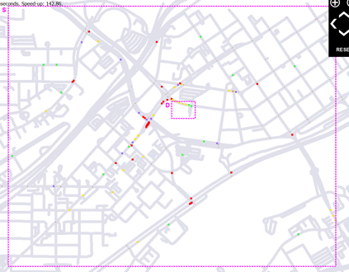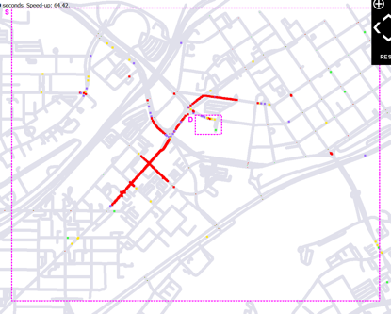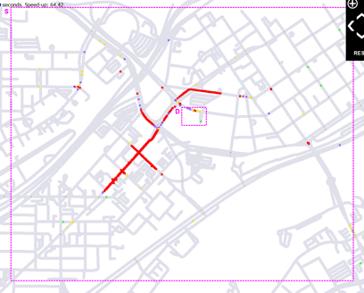

***n = 100*** ***n = 500*** ***n = 1,000***

**Fixed Traffic Light Control**

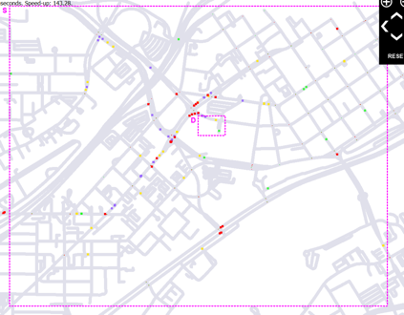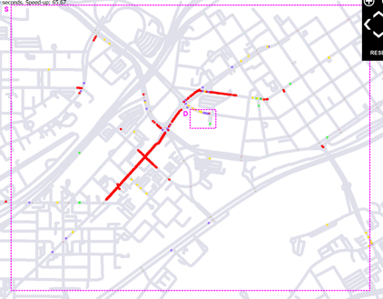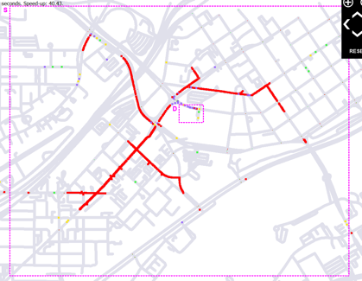

***n = 100*** ***n = 500*** ***n = 1,000***

***Figure 5:*** *Dynamic vs Fixed Traffic Light Control under vehicle capacities of 100, 500, and 1,000. Results indicate traffic conditions at the end of the simulation.*

1. **Conclusion**

Traffic congestion is an important and challenging real-world problem, which aims to minimize the travel time of vehicles especially at the road intersections. Traffic will continue to plague cities as more drivers hit the roads each year. However, current traffic signal control systems in use still rely heavily on oversimplified information and rule-based methods, although we now have richer data, more computing power and advanced methods to drive the development of intelligent transportation. With the growing interest in intelligent transportation using simulation modeling tool like SMARTS, can help us getting the insight detailed information for smart traffic management technologies development without widening roads. We all should continue to look into cutting-edge technology to help the city planner and transportation engineers to build a better future for our growing urban centers.

1. **Sample Simulation Modeling**

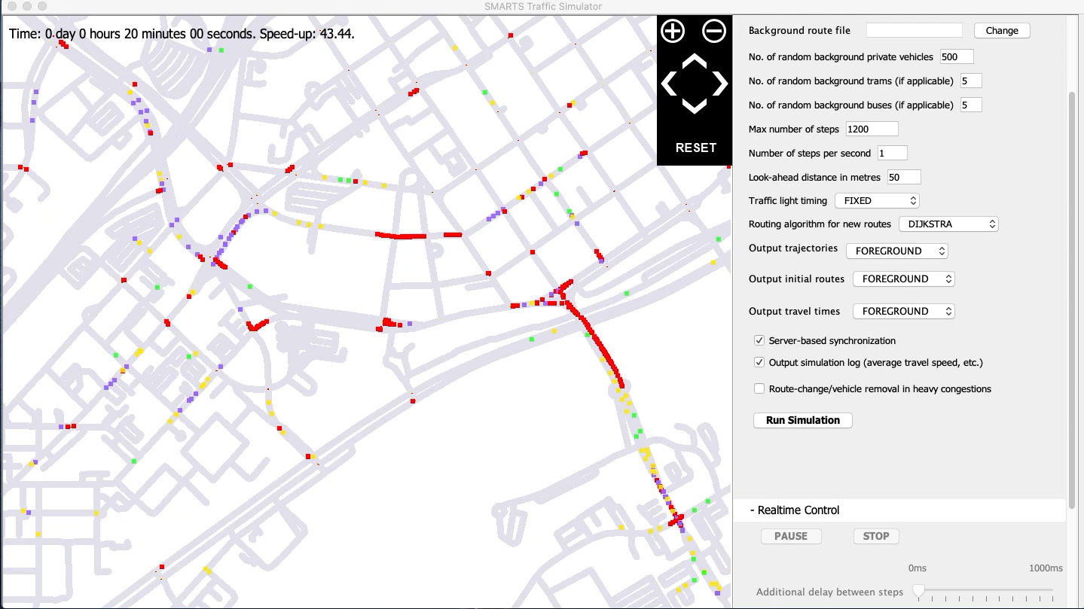Our sample simulation modeling shows below:

Background sample code in Java script:

1. **References**
2. Cheng, R. C. H. 1998. “Random Variate Generation”. In Handbook of Simulation: Principles, Methodology, Advances, Applications, and Practice, edited by J. Banks, 139–172. New York: Wiley.